Documentation Enemy Attack.

# Setting up the AI

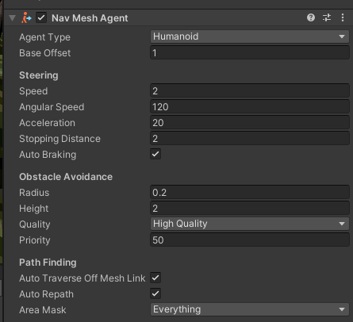

Each AI must have a Nav Mesh Agent. Which tell them that they are allowed to moves around on the Nav Mesh. To set up Nav Mesh or Navigation Mesh is to open up the Navigation tab. Select any ground you using than press bake. It Will Automatic make the ground for the AI to move around And to finish is to also set this agent in the code.

  
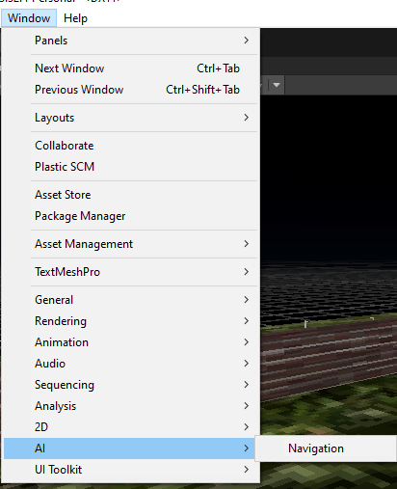 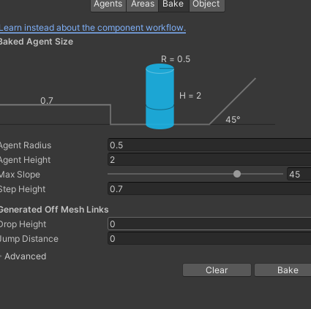

# Setting up a target





These code are variables. The first line of code just make a empty Transform variable name target. Transform is the location Of the object on the map. The second line set the target to the Player Object Transform. Player Manager just shows if the game is running, and instance check if the player object exist.

# Area Scan





The Look Radius allow the enemy to see all around in ten feet. The Distance variable shows the difference of the target position and the Enemy position. Since the code is inside enemy. The enemy transform variable already exist so we can use it right away. The Vector3.Distance is a math function between position.

# Chasing the target

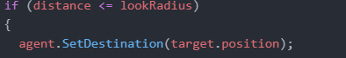

This if statement checks if the player in the enemy view if yes. This Enemy will have it destination to the player position which make the enemy to chase the player

# Attack



The if statement check if the enemy close enough to attack. The Timer get reset after the function is called and it use Time.deltaTime function to get it seconds. Time.deltaTime is a read only function that track the time every 0.02 seconds.

 First the player health must be defined.

Since the Take Damage function is define in the health bar code.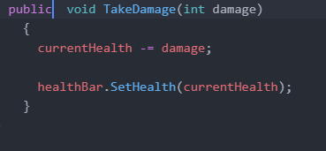 We can actually call the function in the enemy code by using. It calls the function and deal 4 damage.  
